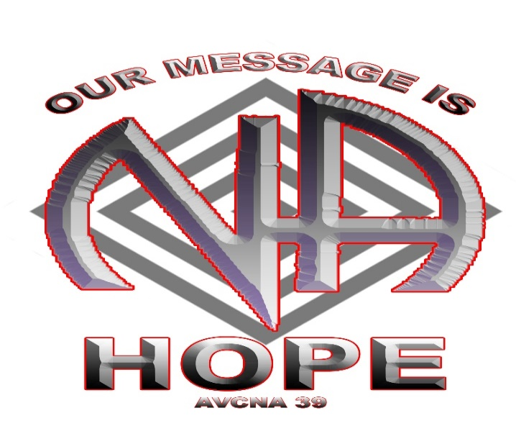
JAN 21st - 23rd, 2022
AVCNA 39 Host Committee
Chair: | Sarah M. | (540) 671-1487
Vice-Chair: | Thaddeus M. | (304) 676-2098
Secretary: | Norman C. | (540) 931-5042
Treasurer:  Vice Treasurer: | Stephen P.  VACANT | (540) 539-2177  -------------

Reserve your room now to get the Convention Rate:
Hotel Madison & Shenandoah Valley Conference Center
710 S. Main Street, Harrisonburg, VA 22801
Reservations: (540)564-0200
$149 per night for single or double occupancy
($10 for additional persons)
Self-parking is $5 per day
(free for overnight guests)

AVCNA 39 Subcommittee Chairpersons
Additional Needs | David T. | (540) 514-5077
Arts and Graphics | Kevin I. | (202) 944-0386
Convention Info | VACANT | --------------
Entertainment | VACANT | --------------
Hospitality | Annette D. | (571) 212-6827
Merchandise | Bill T. | (202) 904-5544
Pre-Convention | VACANT | --------------
Program | Sean R. | (304) 671-4155
Registration | Meredith S. | (703) 582-5639

MAIL PRE-REGISTRATION MUST BE POSTMARKED BY DECEMBER 31, 2021
Check or money orders payable to AVCNA 39 Registration, P.O. Box 3207 Winchester, VA 22604
www.avcna.org
$30 (cash) - $32 (card) until Oct. 31, 2021  $40 (cash) - $42 (card) beginning November 1st, 2021 
ON-SITE REGISTRATION $45 (cash) - $47 (card)
Please note: Merchandise online pricing includes $2.00 surcharge for credit/debit
Main Speakers: 5-yr minimum clean time, please submit tape to PO Box 3207, Winchester, VA 22604
Workshop Speaker: 3-yr minimum clean time  Workshop Chair: 1-yr minimum clean time
If interested in speaking, contact Sean R. (304) 671-4155
REGISTRATION QTY: ______ NEWCOMER DONATION _______TOTAL: $ ___

Name: Email:

Address, include State and Zip Code:

Phone: Additional Needs: _________________________________________

